

St. Peter’s College  
Sabayle St., Iligan City  
College of Computer Studies

ON-THE-JOB Training

At

**LCD Outsource Iligan**

In Partial Fulfillment

Of the Requirement of the Degree of

Computer Science

Submitted by:

**Edward Jr A. Cabello**

**TABLE OF CONTENTS**

**CHAPTER 1 Brief History/Background of the Company or the Company 3**

**CHAPTER 2 Weekly Progress Report 4**

**CHAPTER 3 Assessment of OJT Program 8**

* What have I learned from the experience?
* My experience with the people around me.
* The most memorable event during my OJT.
* What I can recommend for the improvement of the OJT Program
* My advice to those who will take their OJT in the future.

**CHAPTER 4** Pertinent Documents **10**

Application Letter

Resume

Recommendation Letter

Memorandum of Agreement (MOA)

Parent Consent  
 Medical Certificate

OJT Evaluation (Prelim, Midterm, Pre-Final and Final)

DTR

Certificate of Completion

Workplace Documentation

# **CHAPTER 1**

**Brief History/Background of the Company or the Company**

LCD Business Process Outsourcing Services (LCD Outsource Iligan) is a company that was founded in 2011 with humble beginnings as a small business doing basic online services for clients from the US, started by Mr. Lincoln O. Diaz Jr together with some of his friends. Over the years, LCD Business Process Outsource has steadily grown and expanded it’s services to become a key player in the outsourcing industry that made Mr. Diaz Jr. decide to formally register LCD as a BPO Company here at Iligan City, Philippines.

In it’s early years, LCD Business Process Outsource focused on providing basic outsourcing services such as data entry, customer support, and back-office operations for small businesses. As the demand for outsourcing increased, LCD BPO adapted and evolved its service offerings to cater a wide range of industries and clients.

Through strategic partnerships and commitment to delivering high-quality services, LCD Business Process Outsource established itself as a reliable entrusted outsourcing partner for businesses looking to streamline their operations and reduced costs. The Company’s dedication to customer satisfaction and continuous improvement has helped it build a solid reputation in the industry.

Today, LCD Business Process Outsource is a thriving outsourcing company that offers a comprehensive suite of services including CCTV Surveillance and Monitoring, I.T Outsourcing, Finance and Accounting, and more. With a strong track record of success and a customer-centric approach, LCD Business Process Outsource continues to grow and innovate in the competitive outsourcing market.

# **CHAPTER 2**

**Weekly Progress Report**

Edward Jr A. Cabello

**Week #:  1**

**Feb. 8, 2024:** Cleaning PC and Installing OS

**Feb. 9, 2024:** Learning NodeJS

**Feb. 14, 2024:** Learning NodeJS

**Feb 15, 2024**: Meeting with the IT Head for a Project on Slack

**Feb. 16 2024:** Making Icons for the project

**Week #:  2**

**Feb. 19 2024:** Making Logo for the Website

**Feb. 20, 2024:** Making icons for allergy, precaution and transfer/discharge

**Feb 21, 2024:** Updating the icons for the app and some bug fixing

**Feb 22, 2024**: Fixing bugs of empty value to null(Coding). Changing logo filetype.

**Feb 23, 2024:** Fixing distorted image and fixing dropdown

**Week #: 3**

**Feb 26, 2024:** Capture the hostname of the browser session

**Feb 27, 2024:** Writing code for cookies and sessions

**Feb 28, 2024:** Writing code for timeout session

**Feb 29, 2024**: Testing the timeout session code

**March 1, 2024:** Fixing missing icons, EXPANDING GRAPH FROM 240 TO 280, and writing code for License key generator

**Week #: 4**

**March 4, 2024**: Developing an Application for License Generator and finding the encoding and decoding of passwords and writing code for lazy loading for images

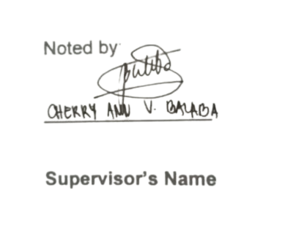

**Weekly Progress Report**

Edward Jr A. Cabello

**Week #: 5**

March 5, 2024: Updating the license key generator.

March 6, 2024: Fixing bugs for license key generator then compiled.

March 7, 2024: Fixing login and logout cookies and making 3D icon and logo.

March 8, 2024: Fixing modals and validating graphs

March 11 2024: Fixing buggy modals.

**Week #: 6**

March 12, 2024: Fixing modal.

March 13, 2024: Fixing modal not saving new data.

March 14, 2024: fixing code for "check license upon login"

March 18, 2024: Fixing license key notification on header.

March 19, 2024: Fixing license upon login and license header notif finally fixed.

**Week #: 7**

March 20, 2024: Fixing BMI and Making Logo  
March 21, 2024: Do not Allow ‘In OR’ event entry to be deleted

March 22, 2024: Fixing date on header

March 25, 2024: Freeze header until search box row for Forms Tab

March 26, 2024: Making Red, Orange, Green Icon for Device Connection Indicator

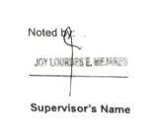

**Weekly Progress Report**

Edward Jr A. Cabello

**Week #: 8**

**March 27, 2024**: Adding Icons to the header and redo-ing expansion of vitals chart (240 - 280)

**April 01, 2024**: Bug fixing on Event entry

**April 02, 2024**: Additional 10 Characters gap between Intervention label and -Total

**April 03, 2024**: Postman API and Mirth Connect API Test

**April 04, 2024**: Continue task "Additional 10 Characters gap between Intervention label and -Total"

**Week #: 9**

**April 05, 2024**: Fixing flowsheet graph

**April 13, 2024**: Continue fixing flowsheet graph and layout

**April 17, 2024**: Volume modal (Joint Task)

**April 18, 2024**: Fixing Modal and Screen refresh (Joint Task)

**April 22, 2024:** Fixing modal and volume SP (Joint Task)

**Week #: 10**

**April 24, 2024**: Fixing date header refresh (Joint Task)

**April 25, 2024**: Fixing Lazy loading on Chart (Joint Task)

**April 28, 2024**: Continue fixing lazy loading (Joint Task)

**April 29, 2024**: Continue fixing lazy loading and adding smart search (Joint Task)

**April 30, 2024**: Smart search fixing (Joint Task)

**May 1, 2024**: Smart search fixing. Continued. (Joint Task)

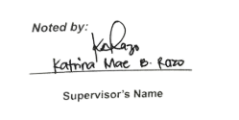

**WEEKLY PROGRESS REPORT**

Edward Jr A. Cabello

**Week #: 11**

**May 02, 2024:** Smart Search Finally fixed. Continuation Lazy Loading and Post Operation Dropdown/Form(Joint Task)

**May 03, 2024:** Continuing fixing smart search (Joint Task)

**May 05, 2024:** Continuing fixing smart search (Joint Task)

**Week #: 12**

**May 06, 2024**: Making Icon for Anesthesia, Monitor, and Infusion.

**May 07, 2024**: Continuing making icons Anesthesia, Monitor, and Infusion

**May 08, 2024**: Fixing Anesthesia and Monitor icons.

**May 09, 2024**: Continuing Fixing Anesthesia and Monitor icons.

**May 11, 2024**: Fixing anaesthesia icons

**May 12, 2024**: Making icon for Device

**Week #: 13**

**May 15, 2024**: Making API for DeviceLayout

**May 19, 2024**: Making 3D Icon for Avatar

**Week #: 14**

**May 20, 2024**: Continuing making 3D Icon for Avatar

**May 21, 2024**: Making column on device route

**May 22, 2024**: Continue fixing column on device route



# **CHAPTER 3**

**Assessment of OJT Program**

1. What have I learned from the experience? (Technical).

I gained valuable insights throughout my on-the-job training experience. Initially, I was intimidated by the unknown, but as I progressed, I discovered that collaborating with others on large projects was not only enjoyable but also beneficial. I learned that working together, sharing ideas, and planning with a team can be a more rewarding and effective approach than going it alone.

1. My experience with the people around me.

I've had the privilege of working with individuals who radiate positivity and warmth. Their enthusiasm and reliability create a sense of comfort and trust. Together, we collaborate seamlessly, like a symphony, tackling complex problems and sharing ideas in a stimulating and nurturing atmosphere. I feel fortunate to have them as colleagues and kindred spirits who brighten every day.

1. The most memorable event during my OJT.

One of the most memorable events during my OJT was when the owner of the company where I was interning treated us to enjoy pizza together. The owner expressed that it was a token of appreciation for our hard work on the project. It was a delightful gesture that not only showed appreciation but also fostered a sense of camaraderie among the team.

1. What I can recommend for the improvement of the OJT Program.

I believe that patience and understanding are crucial for the success of the OJT program. When supervisors and mentors embody these qualities, they create a supportive environment that allows trainees to learn and grow at their own pace. By adopting a patient and understanding approach, trainees will feel more comfortable asking questions and seeking clarification, leading to a more effective and productive learning experience.

1. My advice to those who will take their OJT in the future.

My advice to future OJT takers is to practice patience and understanding, as it won't be an easy journey. Be open-minded, receptive to guidance, and willing to learn from your colleagues. Leave your ego behind and focus on working together as a team, as this will lead to greater efficiency and success.

# **CHAPTER 4**

**Pertinent Documents**

**Edward Jr A. Cabello**

Purok 5 Saray, Iligan City

Lanao Del Norte, 9200

09551071807

January 24, 2024

**Lincoln Diaz Jr.**

Owner / CEO

LCD Outsource Iligan

Roxas Ave, Iligan City

Iligan City, Lanao Del Norte, 9200

Dear Mr. Diaz,

I am writing to express my keen interest in applying for a comprehensive 486-hour On-the-Job Training in your esteemed company. I am a graduating student at St. Peter's College, pursuing a Bachelor of Science in Computer Science. I am eager to leverage this opportunity to gain practical experience in the Tech Field.

Throughout my academic journey, I have acquired a solid foundation of theoretical knowledge in Information Technology. I am enthusiastic about applying this knowledge in a real-world setting and believe that your company, known for its excellence in the Tech industry, would provide the ideal platform for me to do so.

I am flexible with my schedule and committed to fulfilling all responsibilities associated with the trainee position during the training period. My dedication and passion for technology will make me a valuable asset to the LCD Outsource Team.

Thank you for considering my application. I am excited about the possibility of contributing to your team and am eager to learn and grow under your guidance. I look forward to the opportunity for an interview to discuss how my skills and enthusiasm align with your organization's goals.

Sincerely,

**Edward Jr A. Cabello**

OJT Trainee

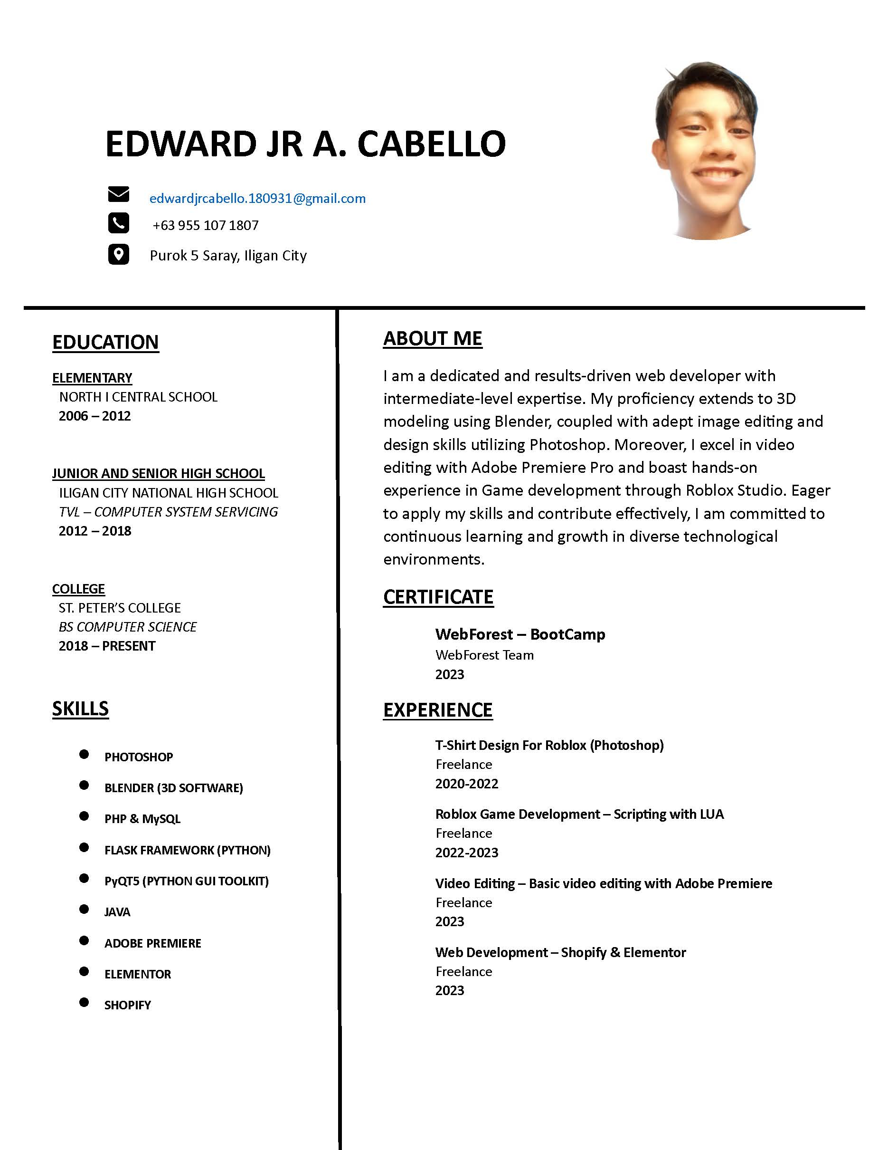

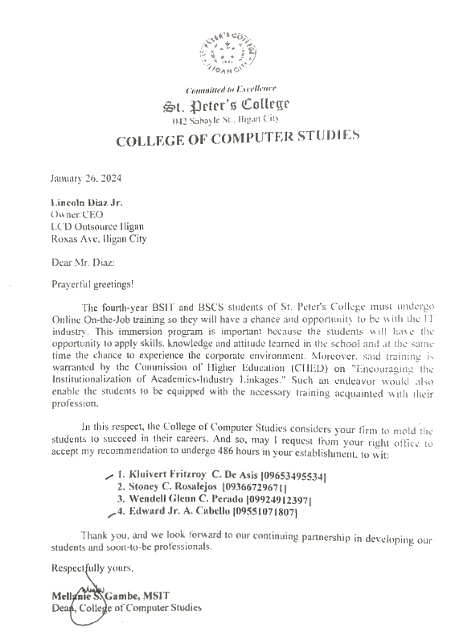

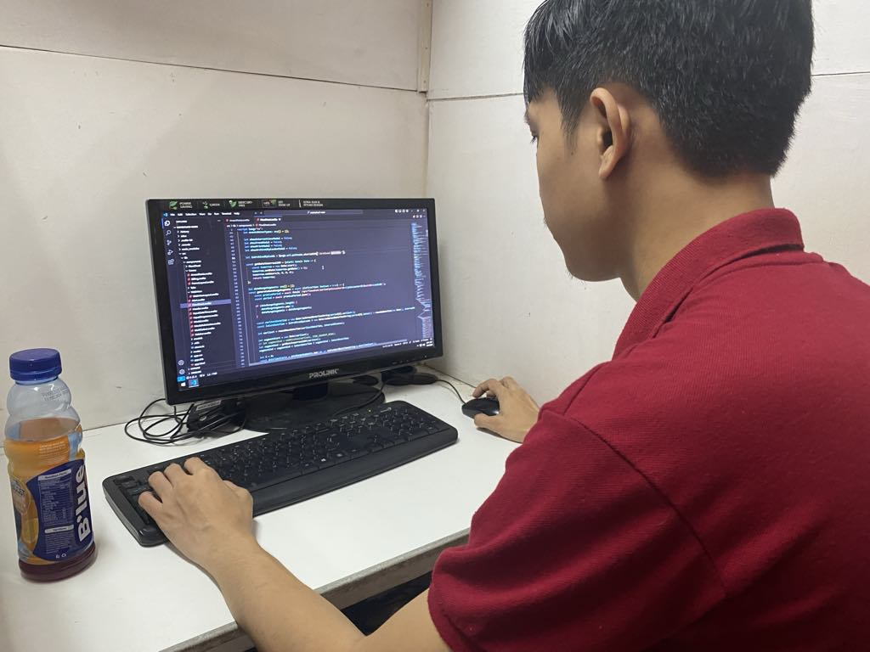**Workplace Documentation**

Coding for the Project

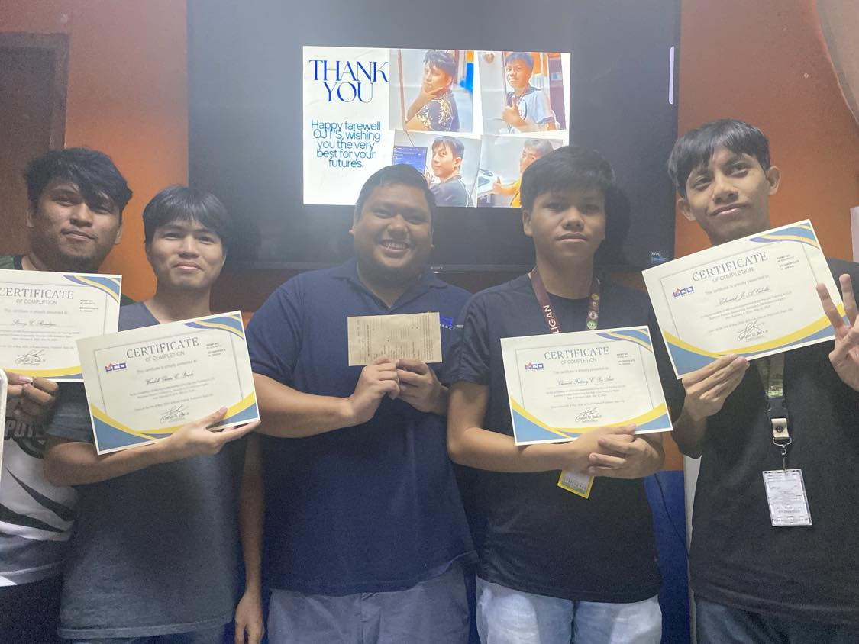

OJT Trainees with Owner, Mr. Lincoln O. Diaz Jr (SPC Trainees from left to right: Stoney Rosalejos, Wendell Glenn Perado, Kluivert Fritzroy De Asis, Edward Jr Cabello)